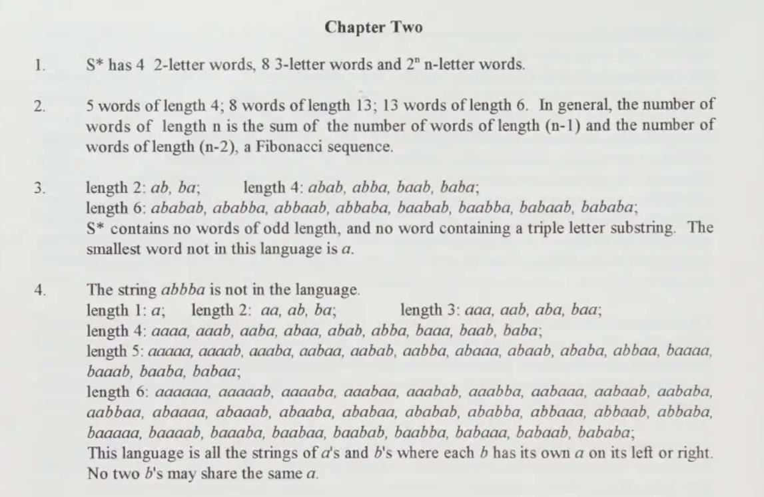

**Solutions Manual:**

[**https://www.scribd.com/document/655101727/Introduction-to-Computer-Theory-by-Cohen-Solutions-Manual**](https://www.scribd.com/document/655101727/Introduction-to-Computer-Theory-by-Cohen-Solutions-Manual)

**Another Solution Manual:**

[**https://www.studocu.com/row/document/university-of-gujrat/theory-of-automata/introduction-to-computer-theory-daniel-cohen-chapter-2-solutions/28691520**](https://www.studocu.com/row/document/university-of-gujrat/theory-of-automata/introduction-to-computer-theory-daniel-cohen-chapter-2-solutions/28691520)